**EXPERIMENT NO. 5**

**DFD:**

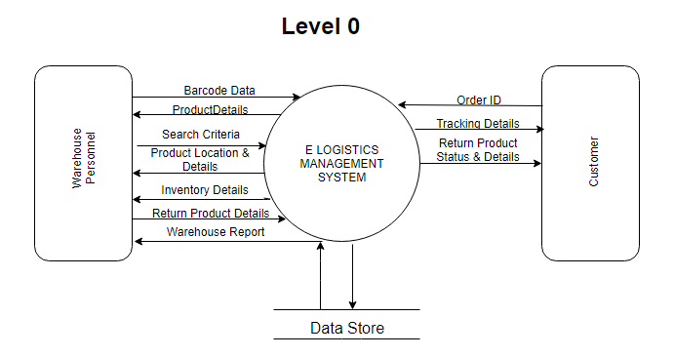

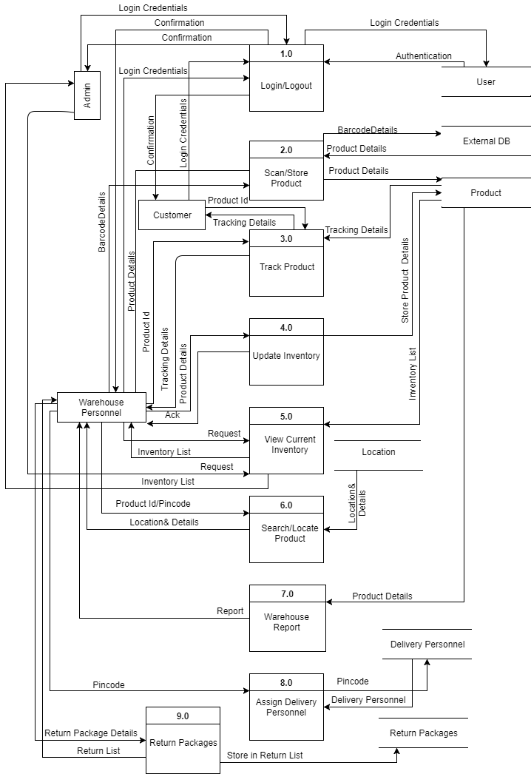

**Strucutred Chart:**

C:\Users\Pranav Mahadik\AppData\Local\Microsoft\Windows\INetCache\Content.Word\Structured Chart.png

**ER Diagram:**

C:\Users\Pranav Mahadik\AppData\Local\Microsoft\Windows\INetCache\Content.Word\ERD.PNG

**Data Dictionary:**

1. Warehouse Personnel

|  |  |  |
| --- | --- | --- |
| **Field Name** | **Data Type** | **Other Information** |
| Id | INT | Primary Key |
| Name | VARCHAR(20) | - |
| Password | VARCHAR(10) | - |
| DOB | DATE | - |
| ContactNo | INT | - |

1. Package Table

|  |  |  |
| --- | --- | --- |
| **Field Name** | **Data Type** | **Other Information** |
| P_id | INT | Primary Key |
| Delivery Address | TEXT | - |
| Location | TEXT | - |
| Weight | INT | - |
| Pincode | INT | - |

1. Customer

|  |  |  |
| --- | --- | --- |
| **Field Name** | **Data Type** | **Other Information** |
| Id | INT | Primary Key |
| Name | VARCHAR(20) | - |
| Password | VARCHAR(10) | - |
| Address | TEXT | - |
| ContactNo | INT | - |

1. Delivery Personnel

|  |  |  |
| --- | --- | --- |
| **Field Name** | **Data Type** | **Other Information** |
| Id | INT | Primary Key |
| Name | VARCHAR(20) | - |
| Pincode | INT | - |
| ContactNo | INT | - |

1. Admin Table

|  |  |  |
| --- | --- | --- |
| **Field Name** | **Data Type** | **Other Information** |
| Admin_id | INT | Primary Key |
| Password | VARCHAR(10) | - |